**CS181 HW4**

**Xiaoming Huang**

1. 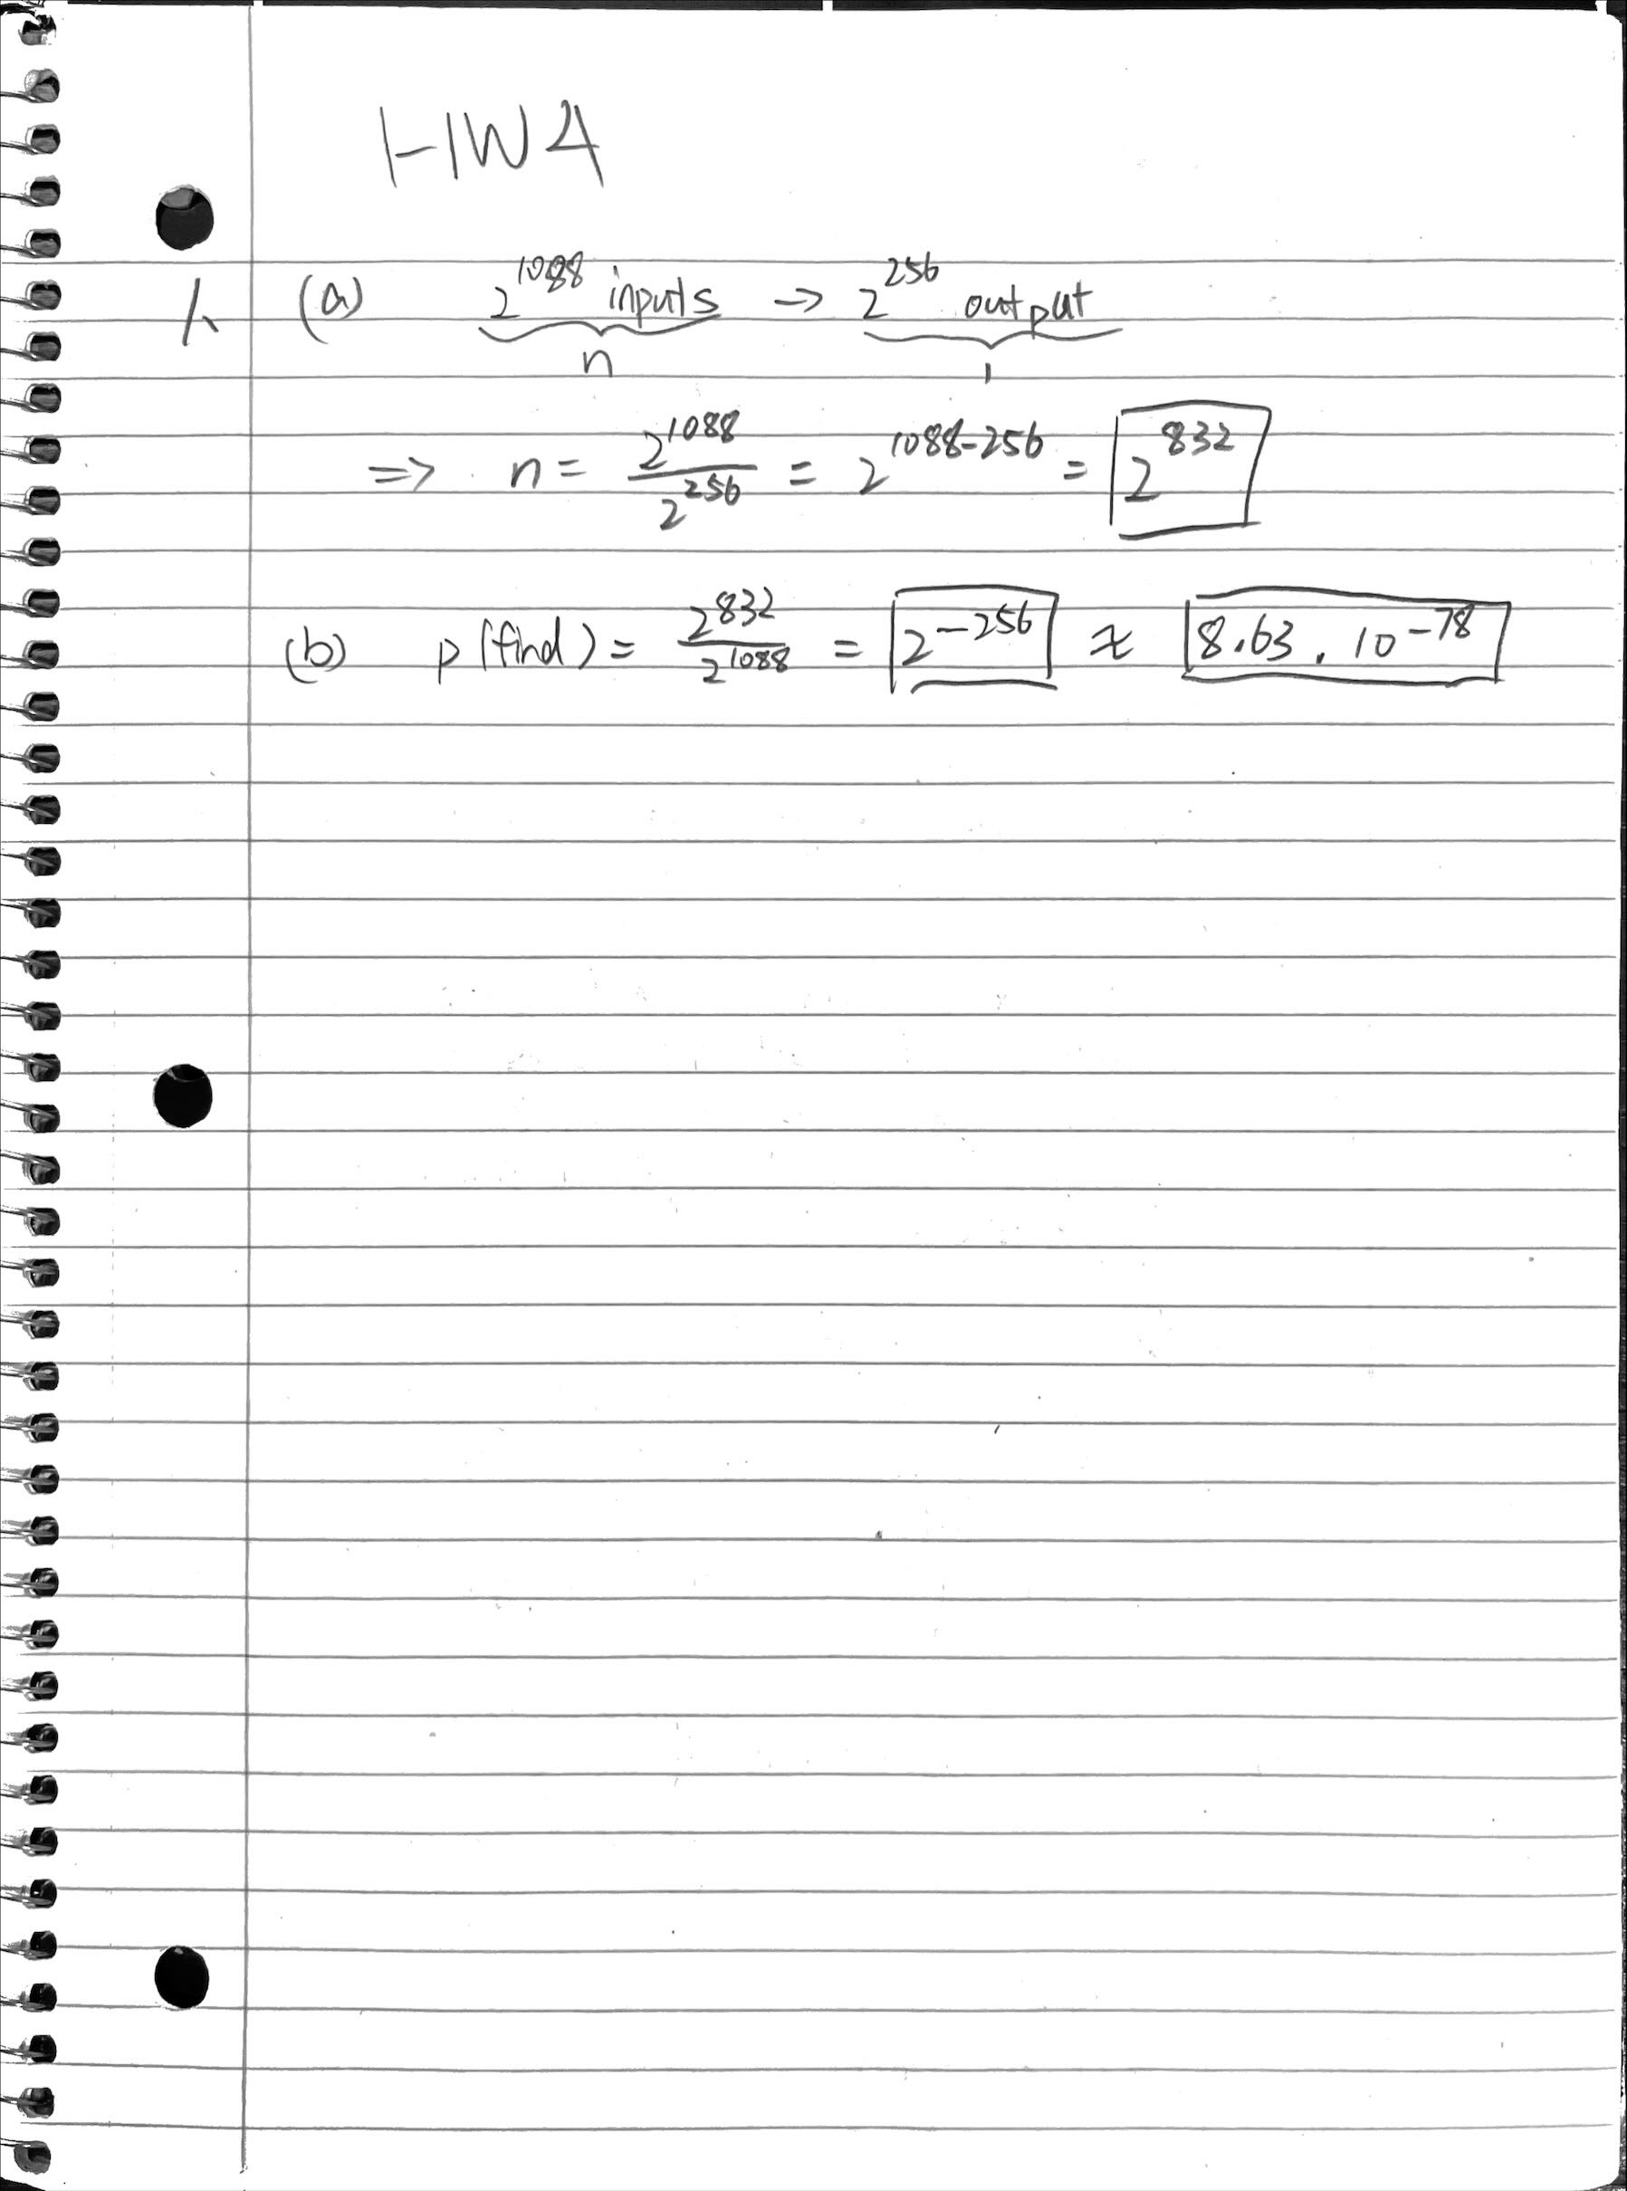**Asd**
2. **a**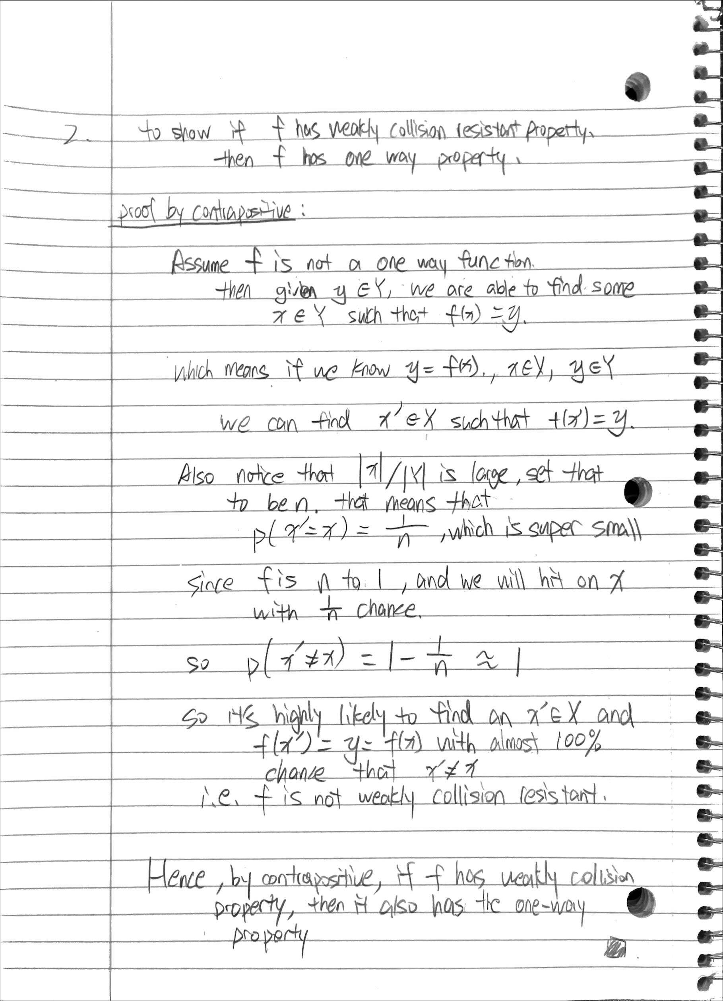

**inputSHA3() is in *345.cpp***

**outputSHA3() is in *345.cpp***

Testing result:

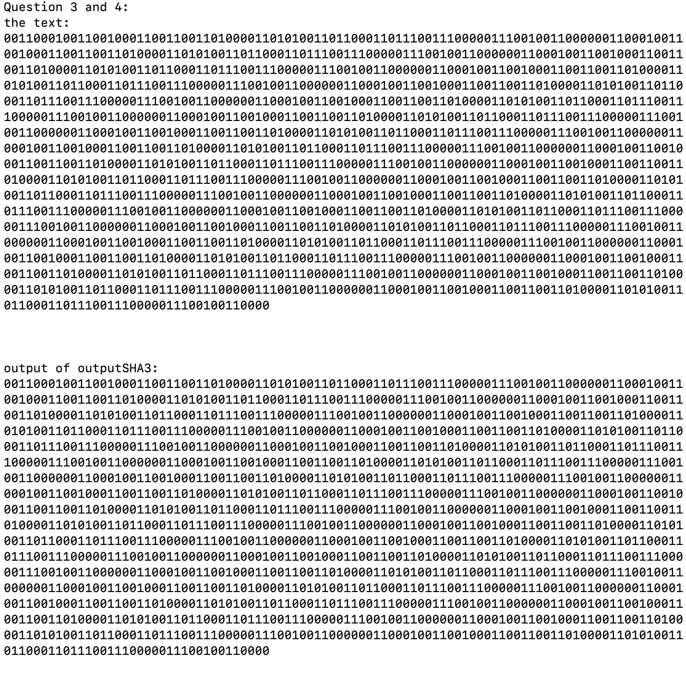

**theta() is in *345.cpp***

calculated value for a_out[4][3][9....18]: 0011011000

calculated value for a_out[3][1][15...24]: **0000101001**